12.60: (a) Get g on Mongo: It takes 4.00 s to reach the maximum height, where v = 0 then 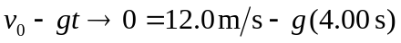
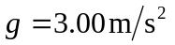
Apply Newton’s second law to a falling object:
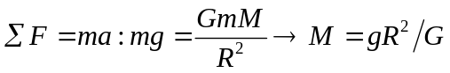
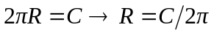
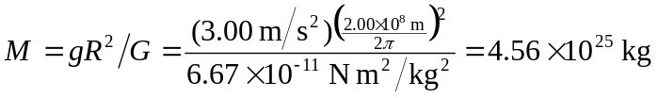
b) Apply Newton’s second law to the orbiting starship.

